   Conference Update
Wednesday 28th June 2000

University of Southern Queensland

Bush Carrier Blues - Panel Discussion.
4.15pm Allison Dickson Lecture Theatre.

Bush Carrier Blues is a Panel discussion on how to satisfy carrier and carriage service provider obligations to facilitate better region telecommunications.

Conference Update caught up with one of the eight panel members to get some forethought on the topic of ‘The Future of the AARNet common carrier exemption status.’
George McLaughlin, Executive Director of AARNet Pty Ltd, Canberra, had this statement to say in brief.
“AARNet members have lived with the restrictions of the current exemptions from the carrier obligations of the telecommunications act, and as a way forward AARNet is considering becoming a carrier”

This is just a taste of what is to be discussed at this afternoons panel discussion on Bush Carrier Blues.

Reminder Notes

- Delegates wishing to attend the golf afternoon are reminded to fill in and return the form in your satchel to secure a tee off time.
- Don’t forget to check out the QUESTnet website. There is lots of information, speaker notes and pictures from the conference.
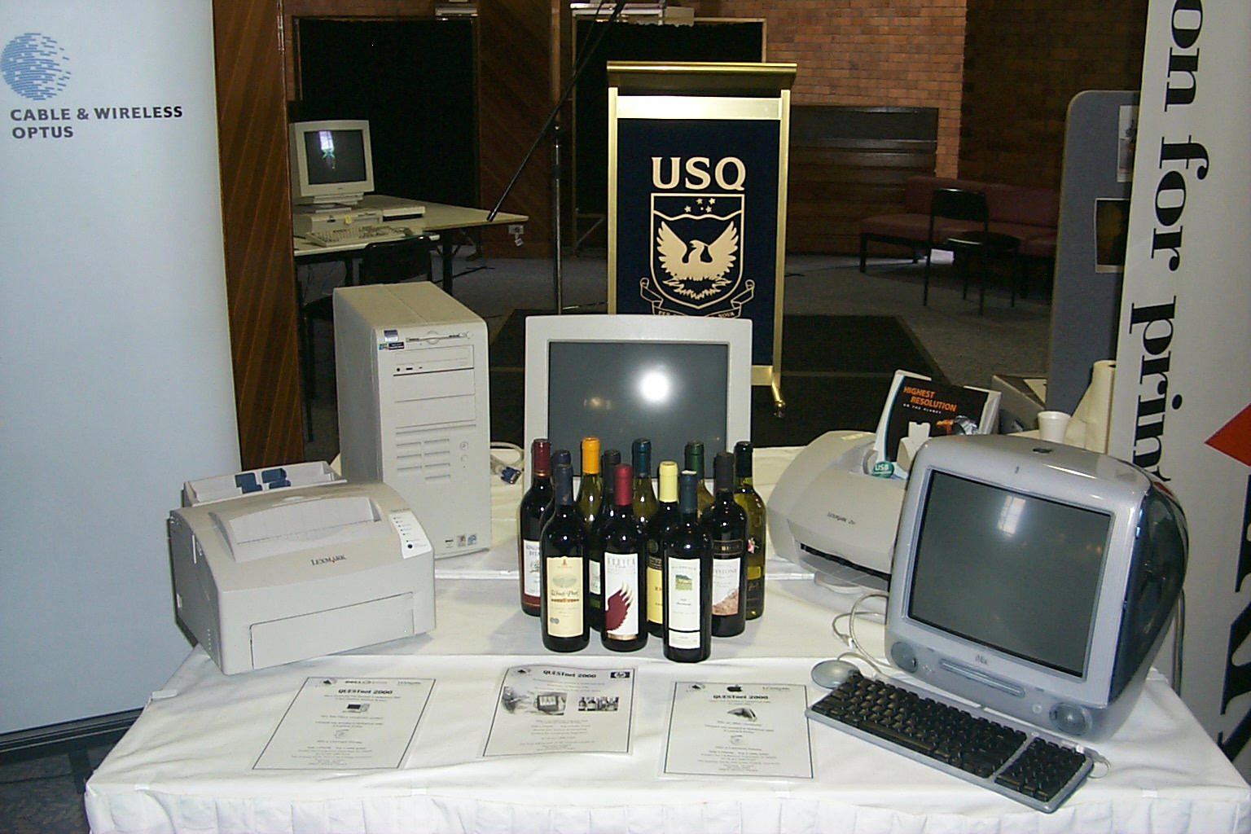
- Raffle tickets are still on sale with all proceeds going to charity. The prizes are on display in the Refectory and worth a look. Good Luck!

Program Changes

Wednesday 28th June - Stream One
11.15am to 12 noon
Helen Wills
Solicitor
Corrs, Chambers Westgarth.

The Facilities Access Regime and the Role of ACCC and the ACA

Session Previously, David Katz – 3Com

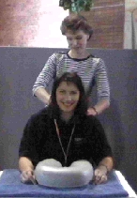Lexmark Trade Display

Lexmark have kindly offered to print in colour any photos from the conference. These photos can be found by following the links contained in the QUESTnet web site.
You might even get a massage!!

QUESTnet So Far.

Professor Peter Swannell officially launched QUESTnet yesterday.

Setting the stage for this years conference was keynote speaker Mr Robin Eckermann, Chief Architect, TransACT Communications. with his address on “Breaking the Last-Mile Speed Limit”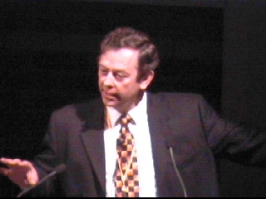.

So far the conference has lived up to its promise to deliver informative and entertaining topics. With a variety of speakers addressing the delegates.

From a social and networking aspect the conference is proving invaluable with many new contacts being established throughout the industry.

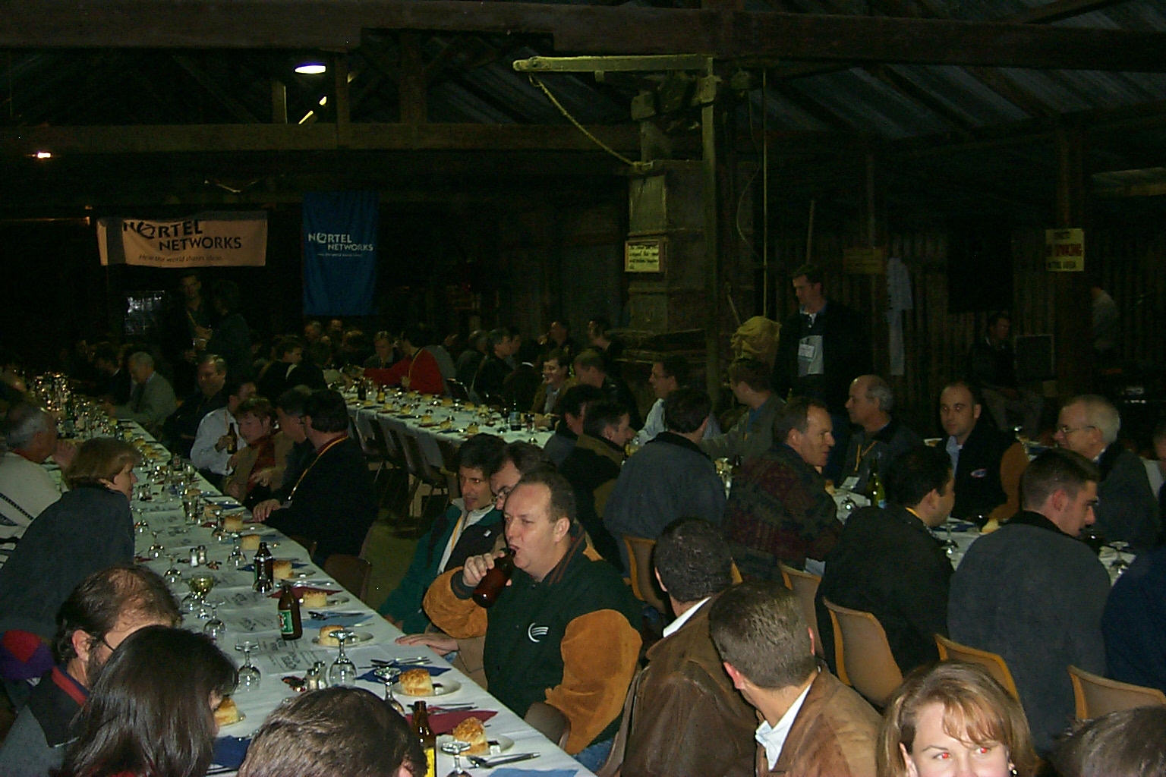
This years social events are something out of the ordinary with last nights bush dinner at Jondaryan Woolshed proving very popular, especially with our overseas guests.

Tonight’s dinner is a surprise. Meeting at the Empire Theatre for pre dinner drinks before being whisked away to a mystery location for a dinner not to be forgotten… plus there will be entertainment of the sort you least expect.

Caught on Camera

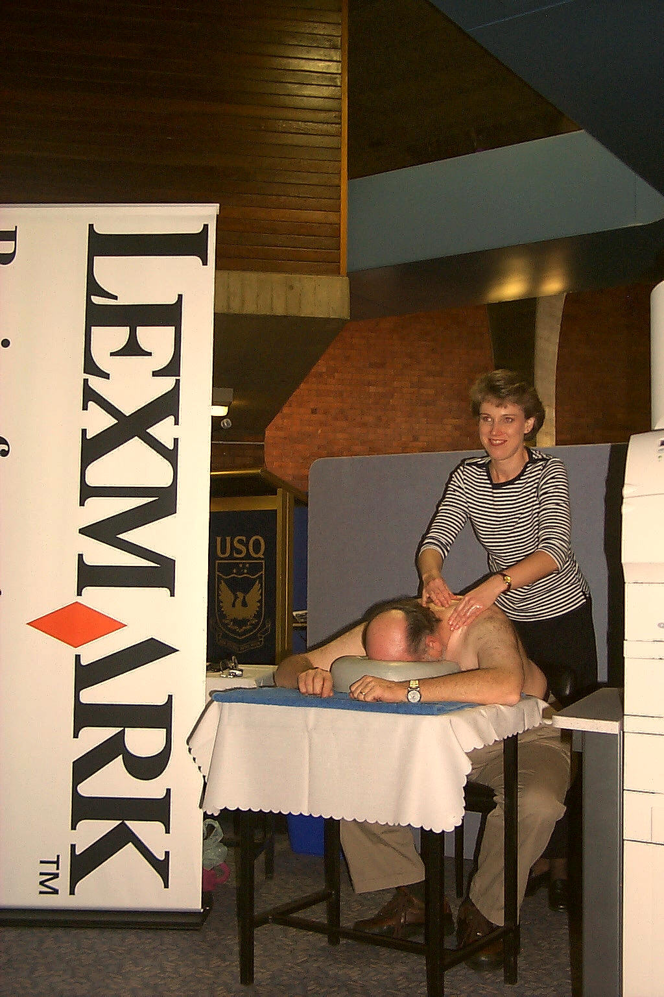
One of the delegates enjoys a massage at the Lexmark Stand.

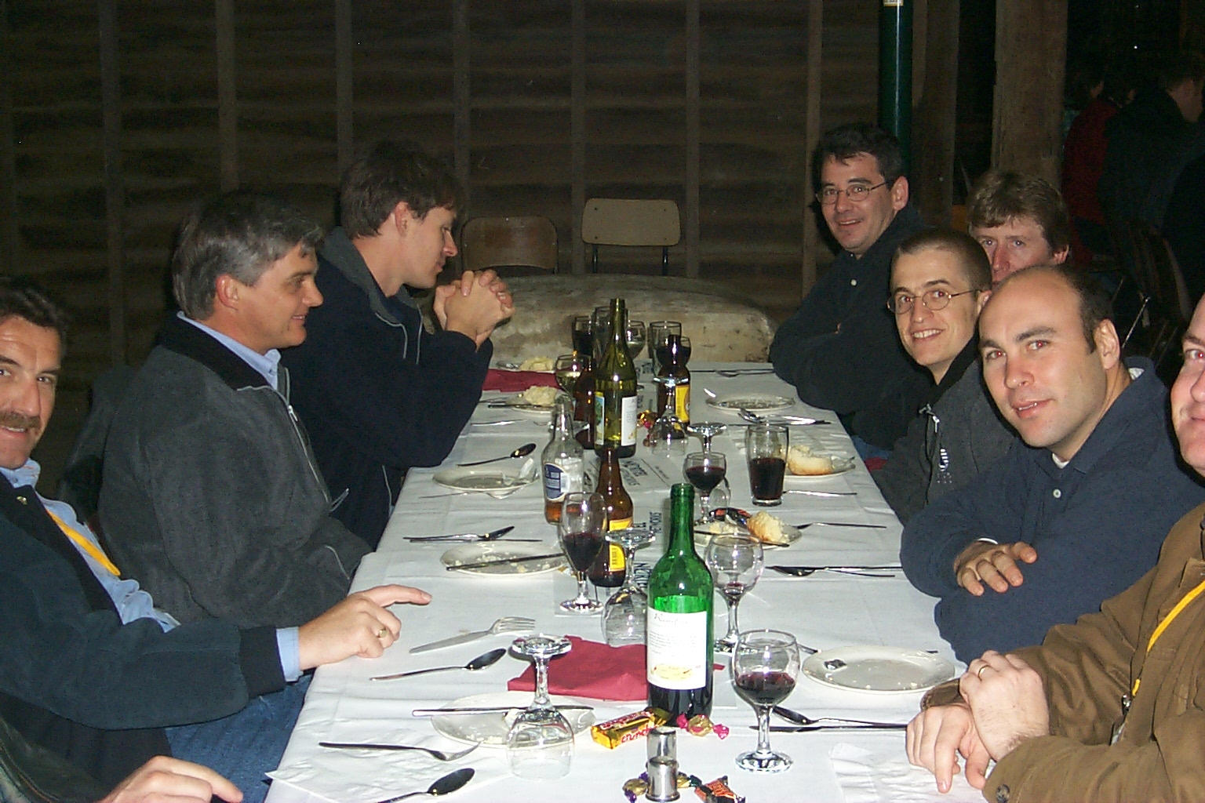
Please Sir, can we have some more…

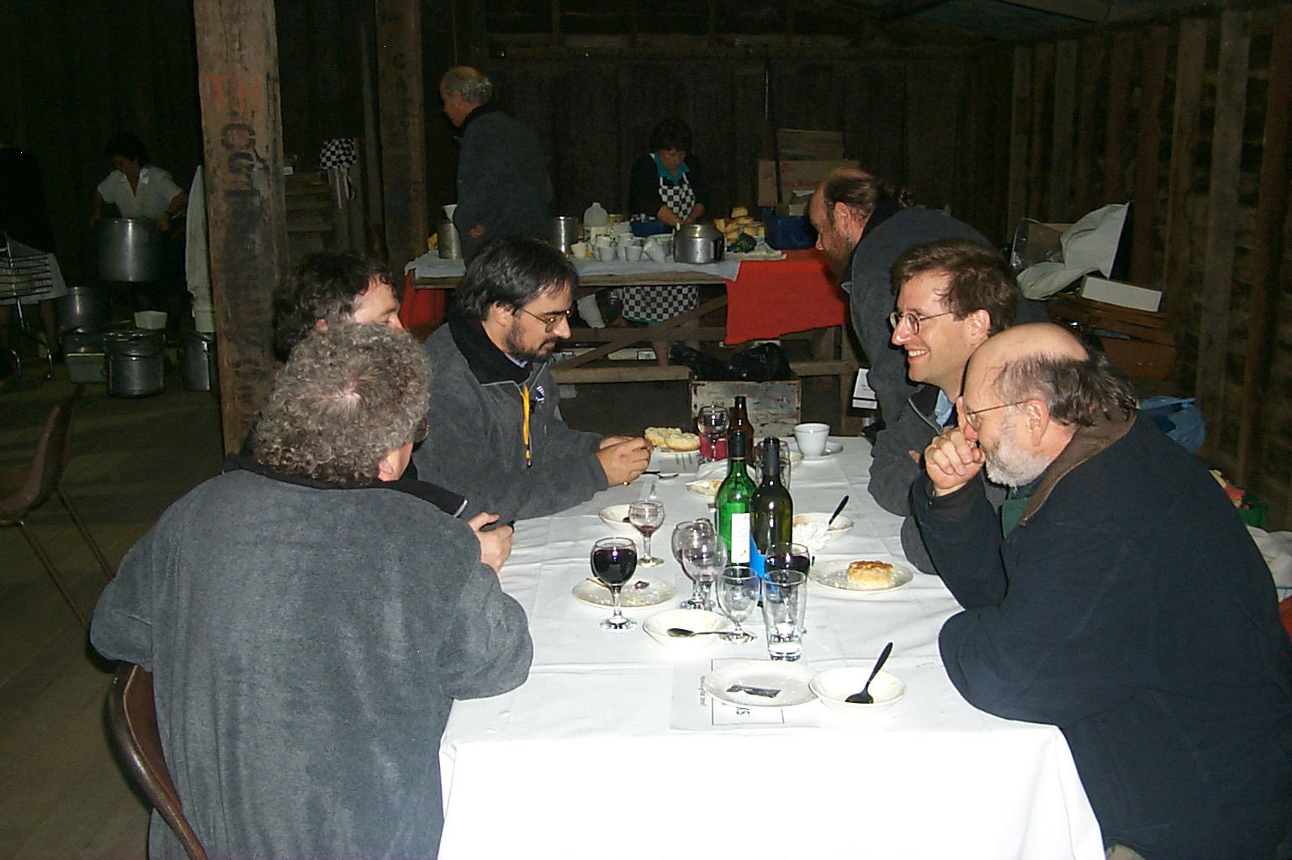

Hmmmm, I agree.

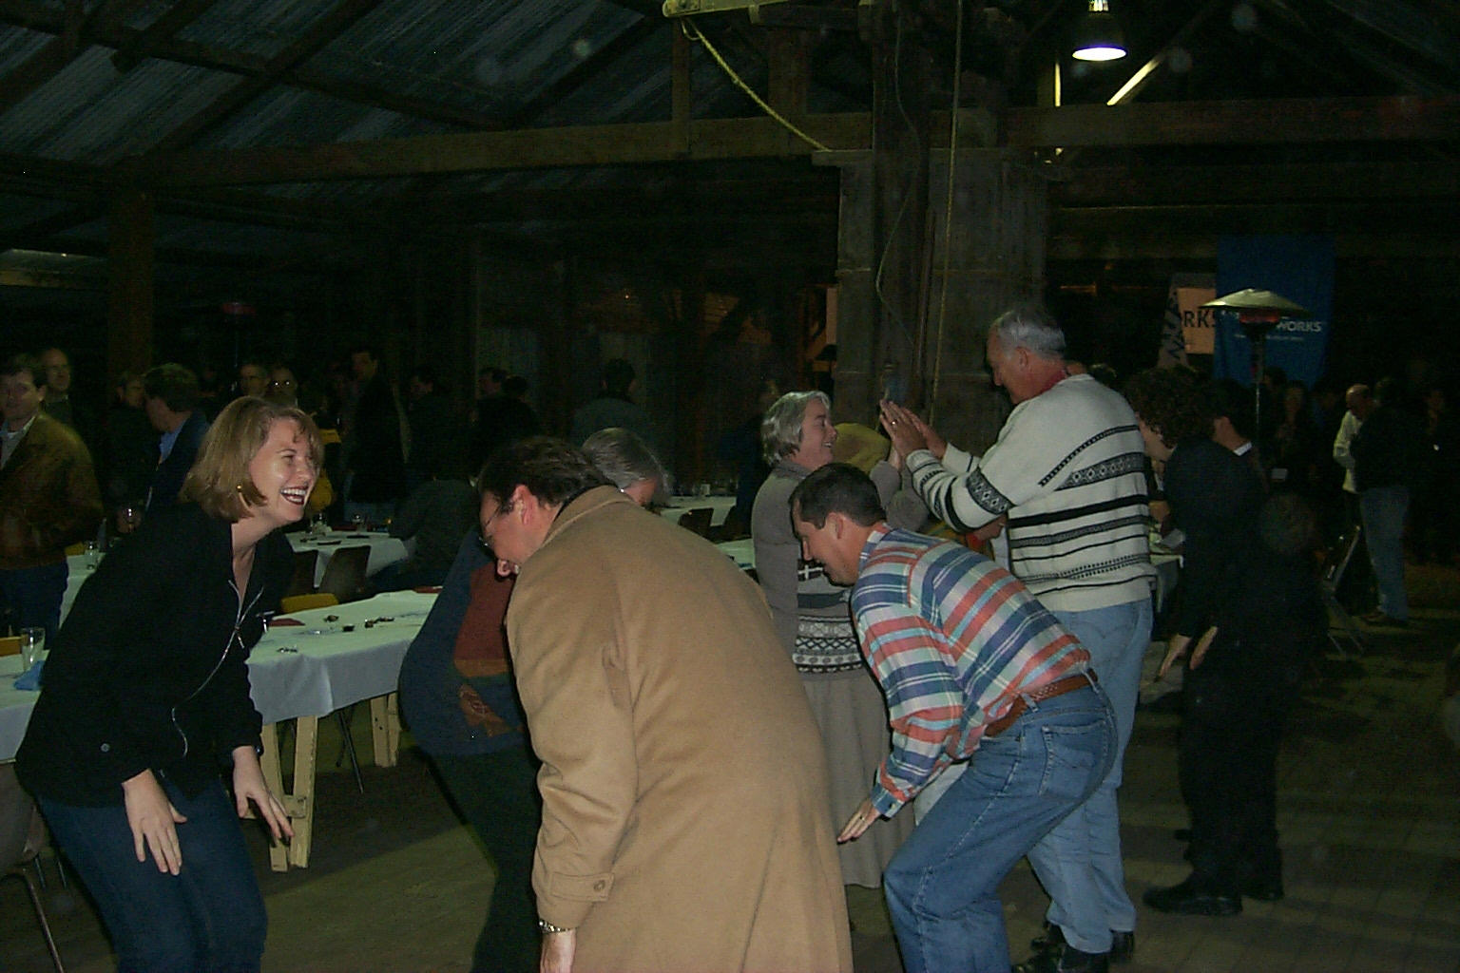
Docie Doo and away we go…

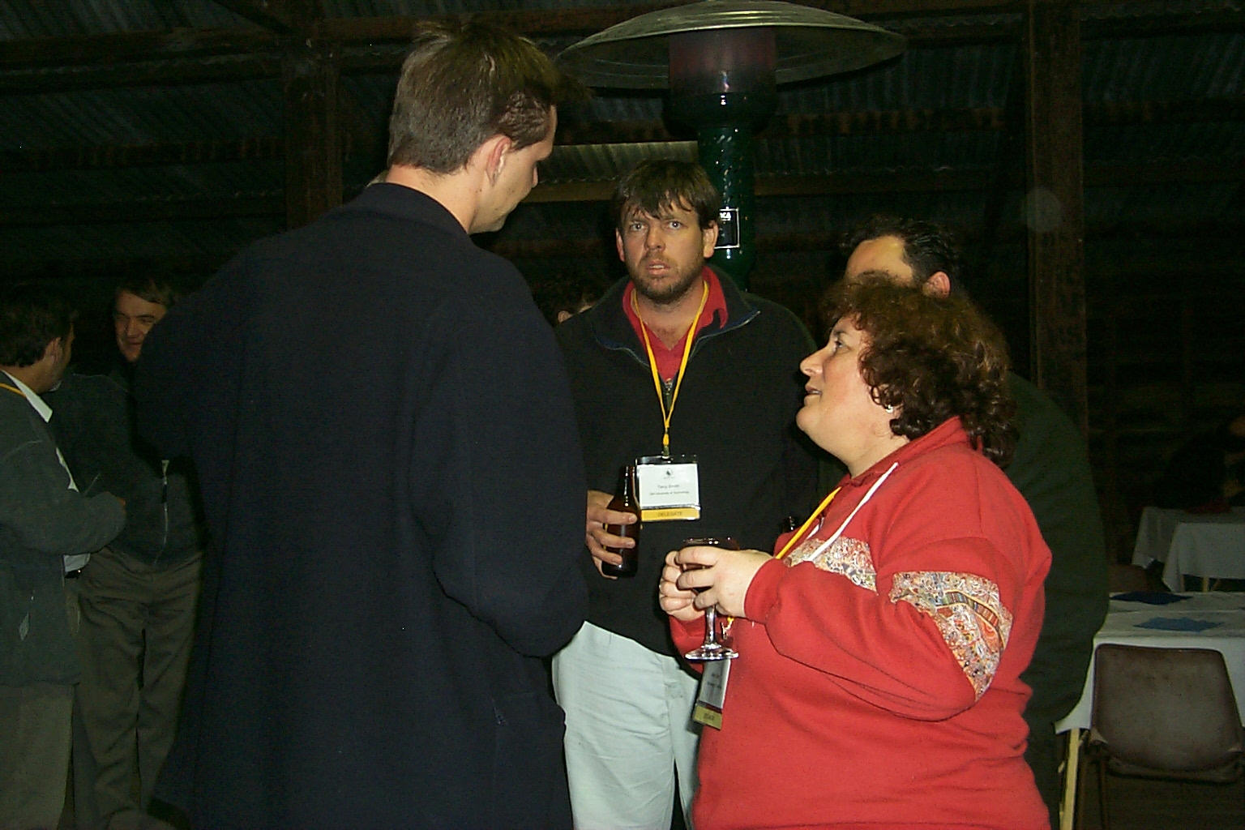
Invaluable networking.

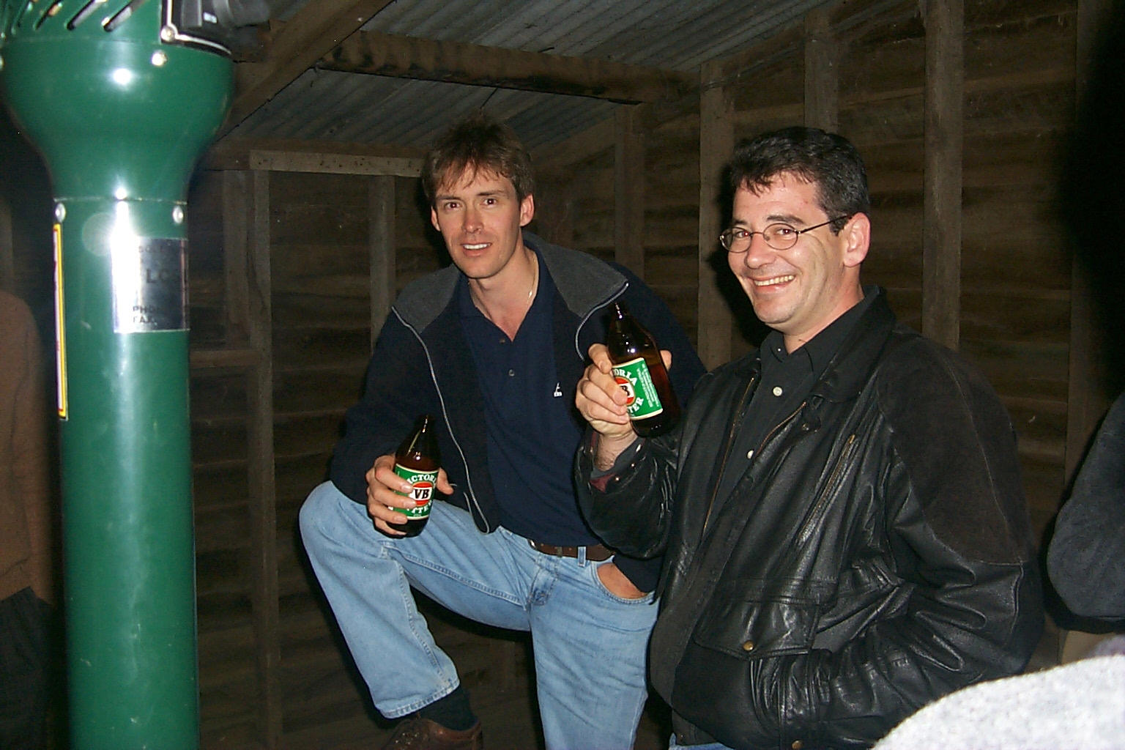
Cheers!!

