   Conference Update
Tuesday 27th June 2000

University of Southern Queensland

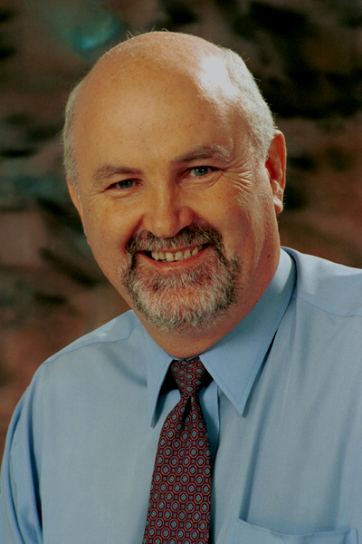 Gidday!

Or as the Nepalese would say – Namaste!

Welcome to QUESTnet 2000 – we hope that we have organised an informative, entertaining and friendly conference for you, and wish you well in your personal networking.

We have a number of very helpful sponsors including Cable and Wireless Optus, who are all willing to talk to you about your telecommunications needs, challenges and situations.

Catch up with you some time over the next three days.

Jeff McDonell
Chair, QUESTnet 2000 Conference Organising Committee.

Program Changes.

Any changes to the program will appear in this newsletter as they come to our attention

Wednesday 28th June - Stream One
11.15am to 12 noon
Helen Wills
Solicitor
Corrs, Chambers Westgarth.

The Facilities Access Regime and the Role of ACCC and the ACA

Session Previously, David Katz – 3Com
Housekeeping.

- Messages and Conference information can be found adjacent the Registration desk in R block.
- Delegates who may need to be contacted during the conference can give the following numbers:
Phone: 0746312476, Fax: 0746312126 (and mention QUESTnet)
- All building on campus are designated non-smoking area.
- This newsletter will be published daily and available at the registration desk.
- Speaker’s notes will be published on the conference web site as they become available.
- Car parking is available to all delegates, however you are asked to observe the University parking regulations. Parking bays with red strips are reserved for USQ staff only.

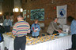

Registration Information.

Conference Registration on Monday 26th of June will take place in the main Refectory of USQ, R block, from 4pm.

The conference information desk will operate at the following times:

Tuesday 27th June 8am – 5.30pm
Wednesday 28th June 8.30am – 5.30pm
Thursday 29th June 8.30 – 12.30pm

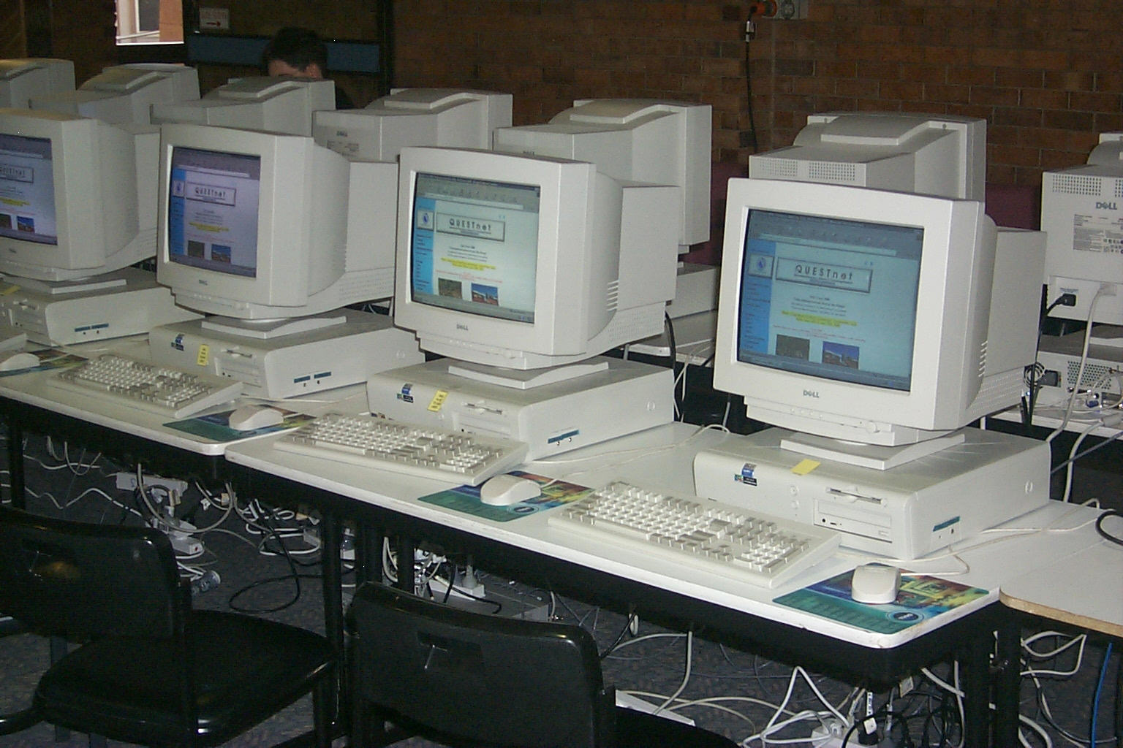Facilities.

Internet facilities are available in the main Refectory, R block and also from the computer lab located on the ground floor of S block

Social Events.

Tuesday – Jondaryan Woolshed.
A night of bush entertainment and food in a traditional style woolshed setting.
Dress very warm, as it can get very cold.
Buses depart 6pm

Wednesday – Empire Theatre.
Meeting at the Empire Theatre for pre dinner drinks before moving to a surprise location for dinner and world class entertainment.
Dress smart casual.
Buses depart 6.30pm

Thursday – Golf Afternoon.
Spend the afternoon playing 9 holes of golf after being served lunch at the Toowoomba City Golf Club.
Numbers are limited so you MUST register by returning your form to the Registration desk; the first 30 people to register will have use of a motorised buggy. So be quick.
Buses depart 12.45pm

Charity Raffles

This year we are holding three raffles with proceeds in aid of the Royal Flying Doctors, Camp Quality and Sister Kenny. The prizes have been kindly donated by our sponsors so dig deep and good luck. More information on these raffles can be found in your satchel.

Rumour Humour
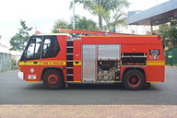
QUESTnet 2000 got off to a blazing start with a visit from the Toowoomba Fire Brigade. No one was harmed however Conference Organisers suspect the cause of the alarm was triggered by a telecommunications fault ☺.

Caught on Camera

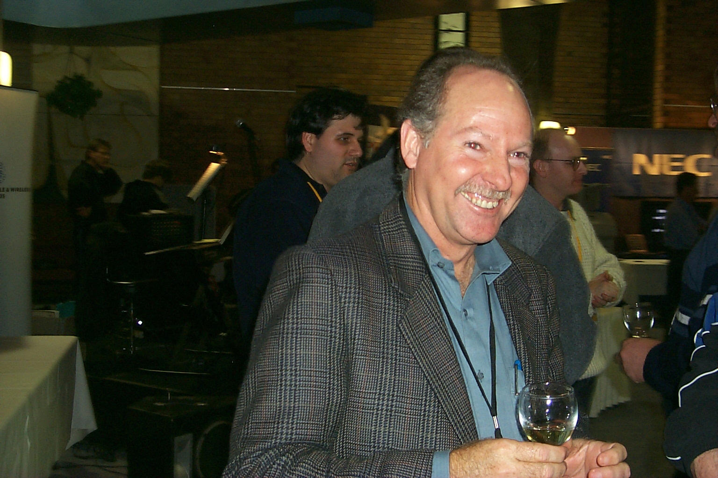

Happy Birthday to Ross Gorham for Monday
26th June 2000.

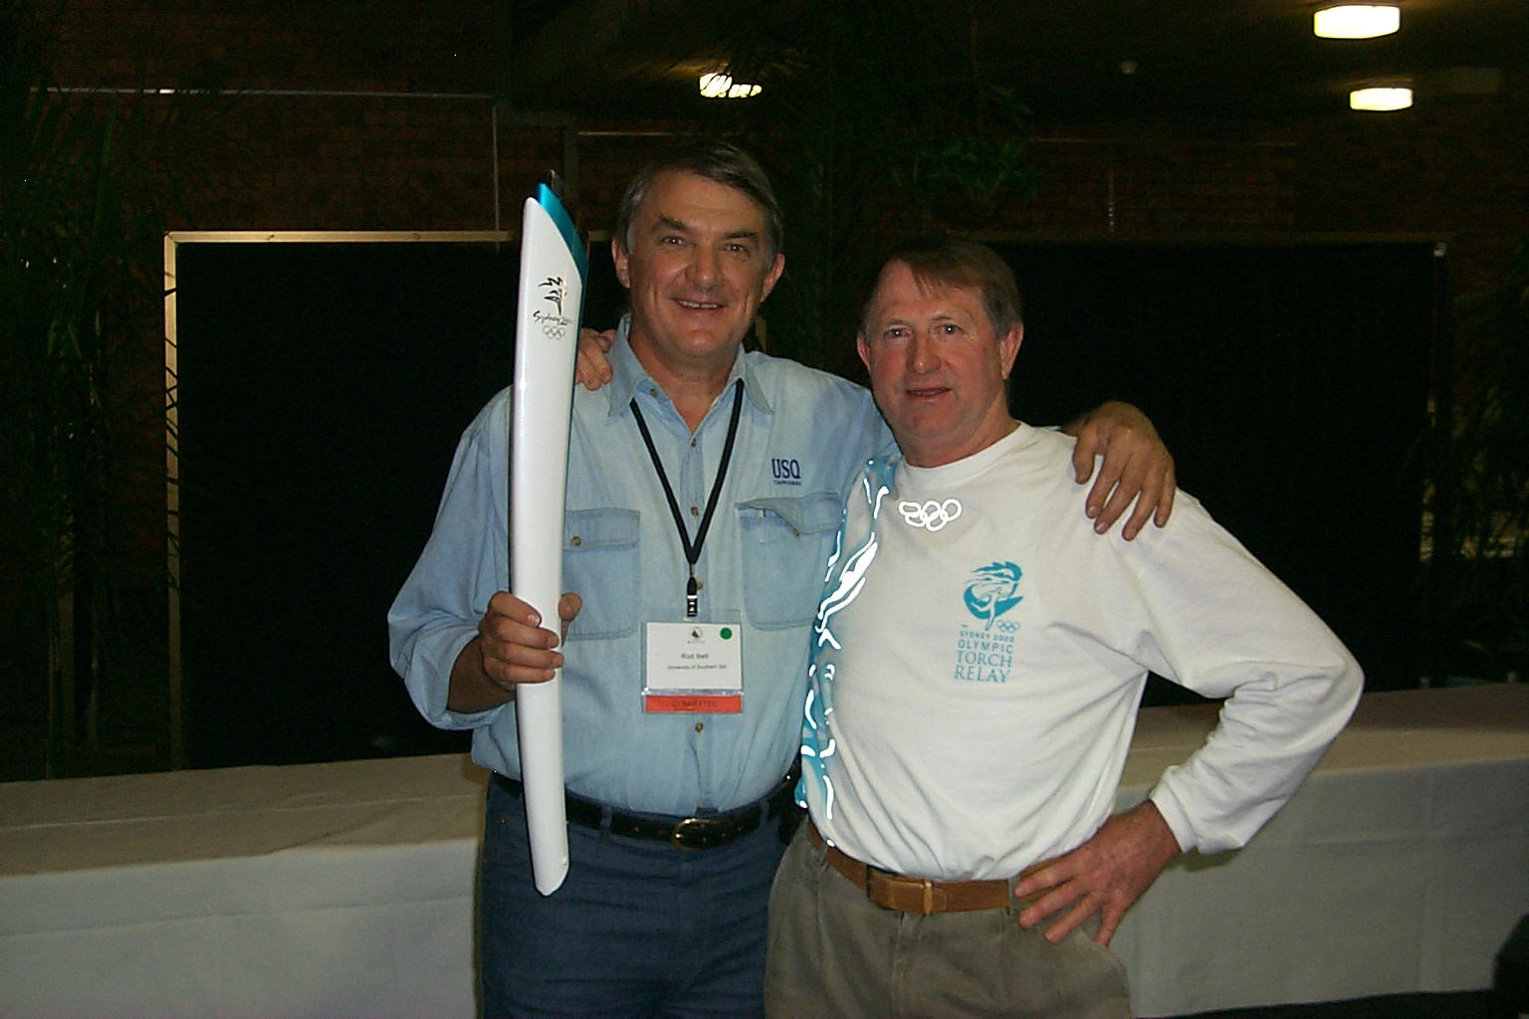

Ibell to Ibell… the Olympic Torch came to Questnet, Courtesy of Ross Ibell.

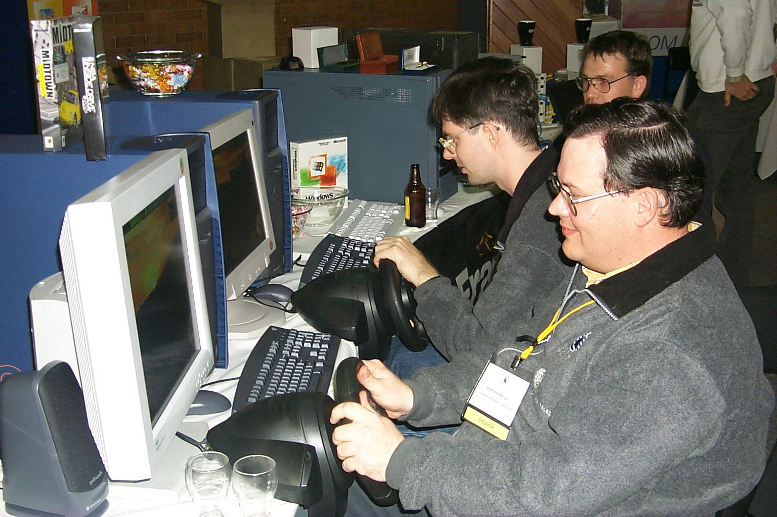

Delegates unwinding at the trade display.

