   Conference Update
Thursday 29th June 2000

University of Southern Queensland

Social High

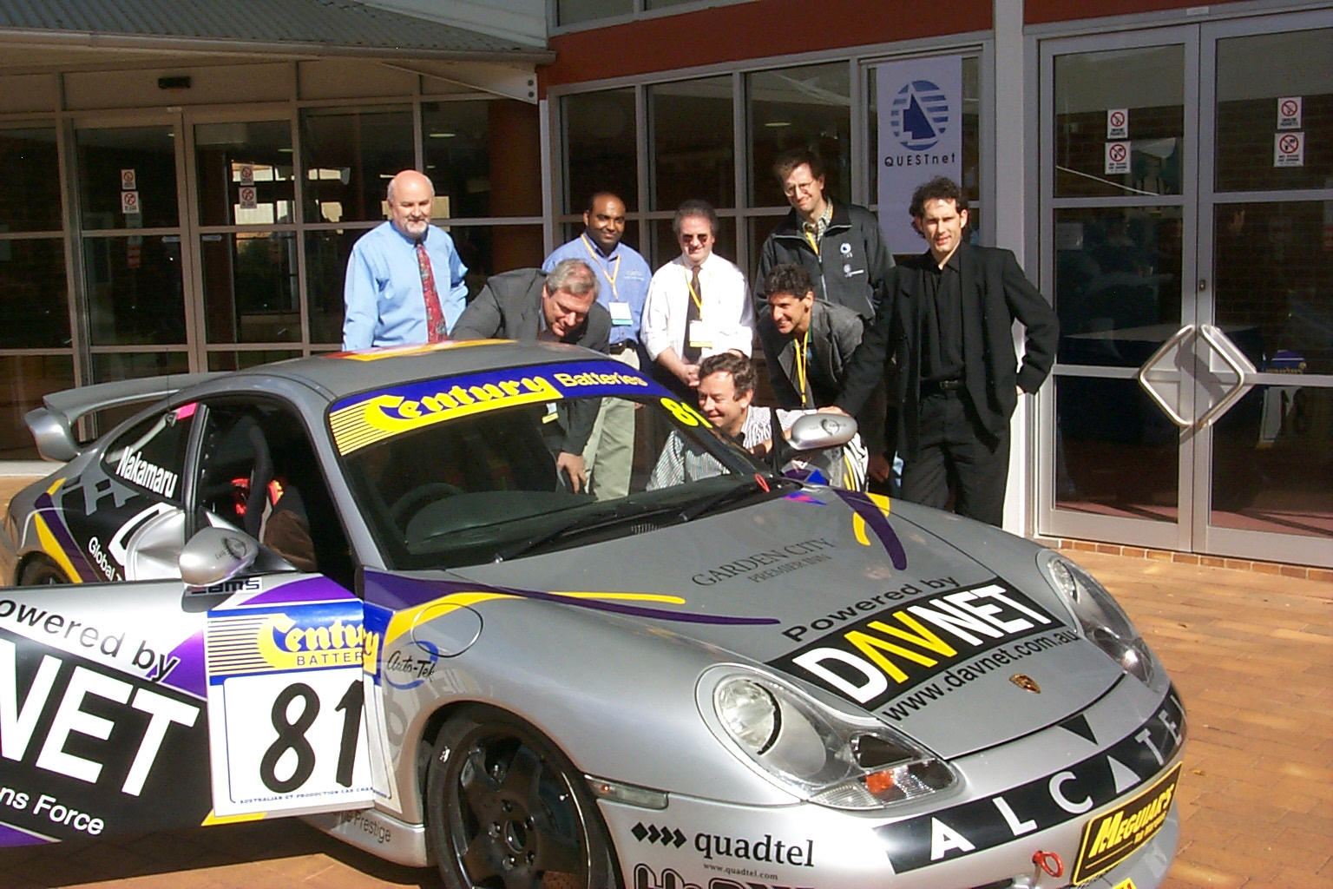

Delegates came together to admire the ALCATEL racing Porche.

ALCATEL kindly offered to have the racing team stop in for a photo shoot on their way to the Willowbank Race Way for this weekends racing carnival.

Photos from the visit can be found on the QUESTnet web site.

Reminder

- Delegates participating in the Golf Afternoon are reminded that the buses leave at 12.45pm from the front of the University. Lunch will be served at the Golf club.
- There will be a bus departing from the campus at end of the day returning delegates to hotels in the city.
- More pictures are available on the QUESTnet web site, so have a look.. And a laugh.

- The three raffles are being drawn at the closing ceremony. So if you haven’t already bought tickets see the registration desk.. After all you have to be in it to win it! Good Luck.

QUESTnet Dinner


Sponsored by

Last nights function at the Empire Theatre went over as a huge success.

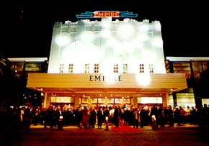

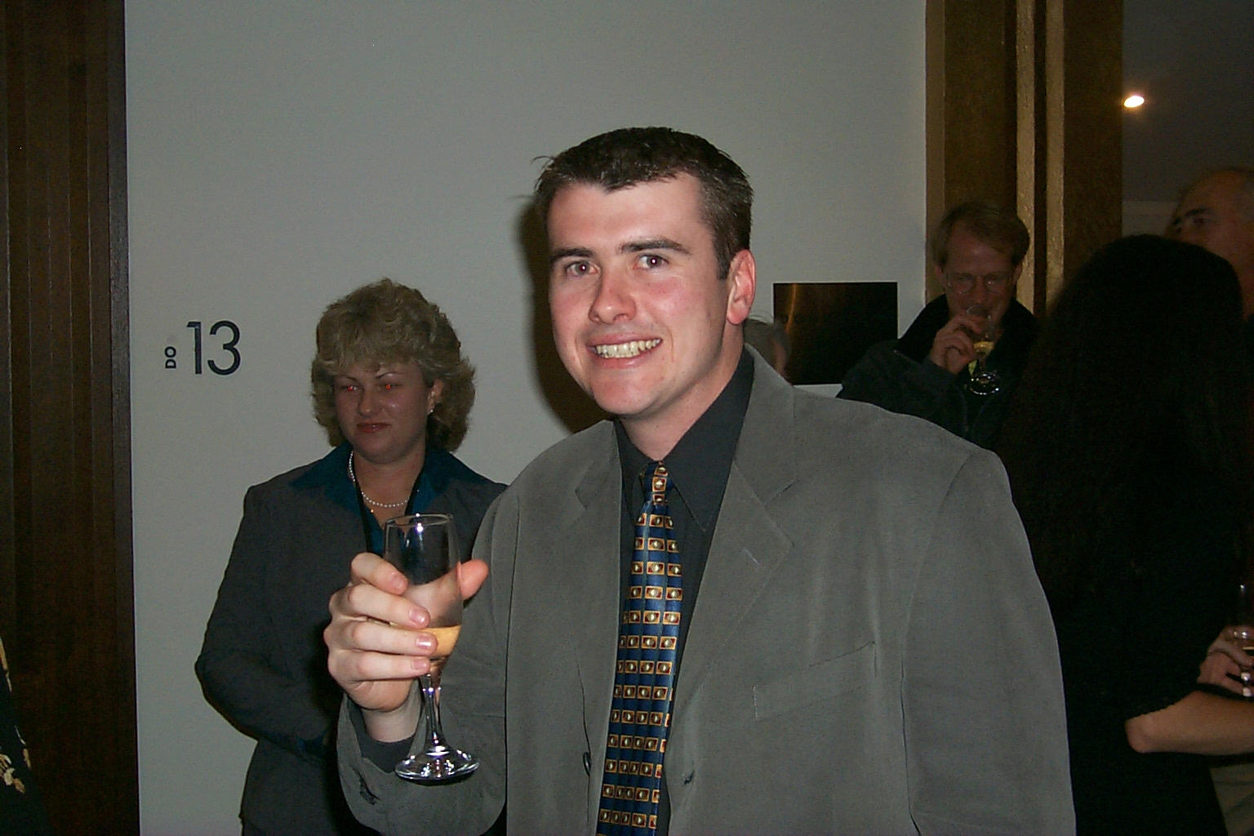
All welcomed the pre-dinner drinks. particularly Josh on his 25th Birthday.

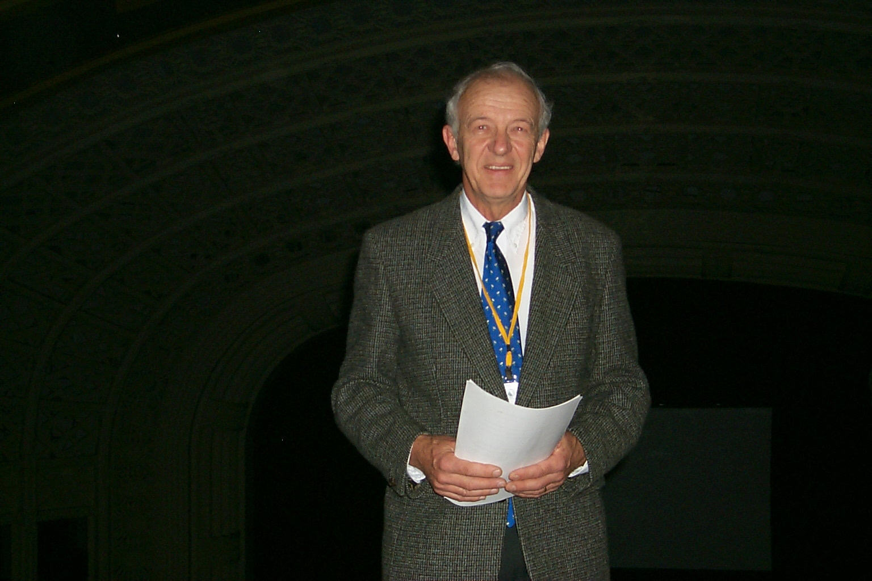
The Empire strikes back as narrated by Keith Hoffmann.

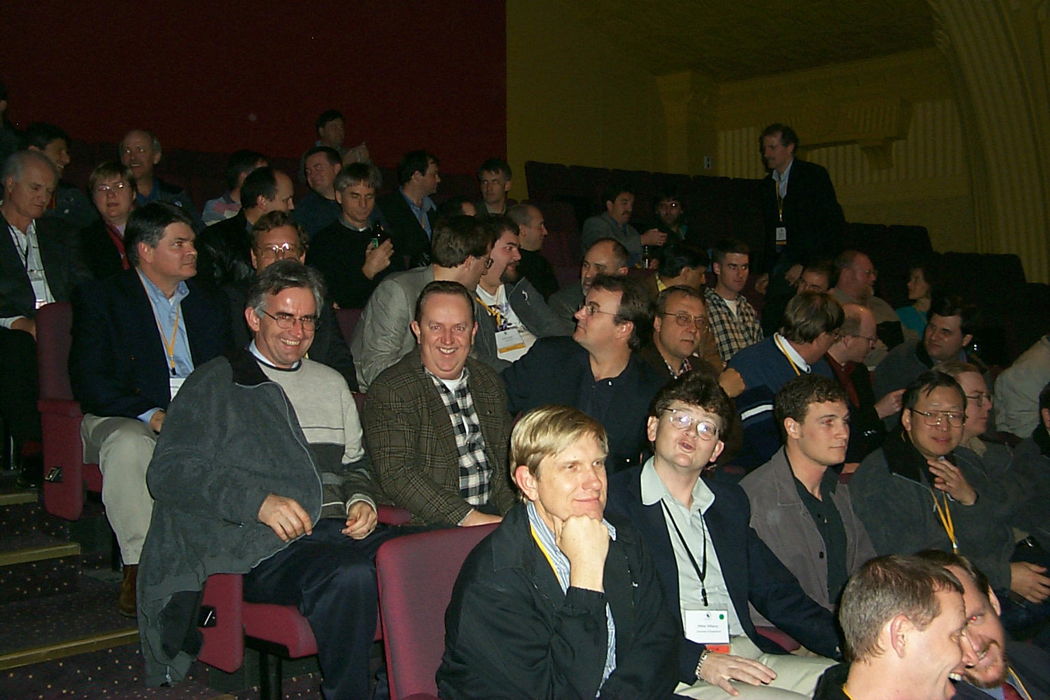
Waiting with baited breath

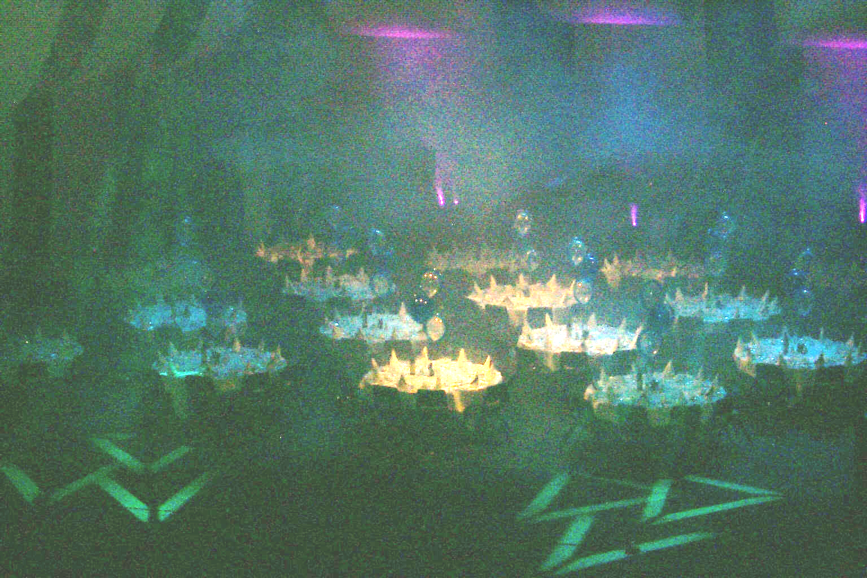
The curtain was lifted to reveal the setting for dinner.

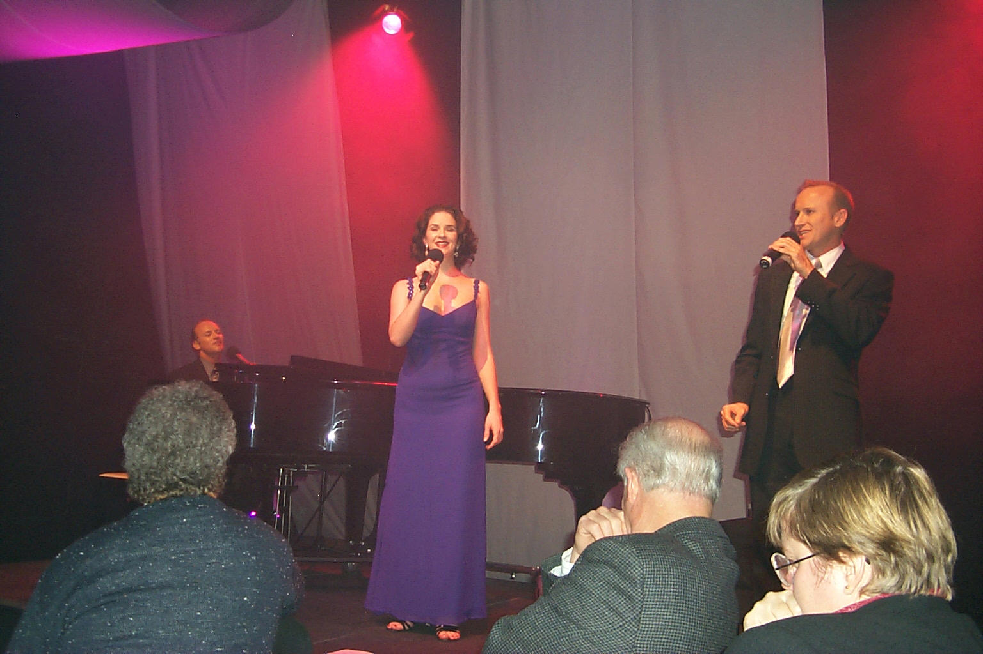
Combo Fiasco… what a performance.

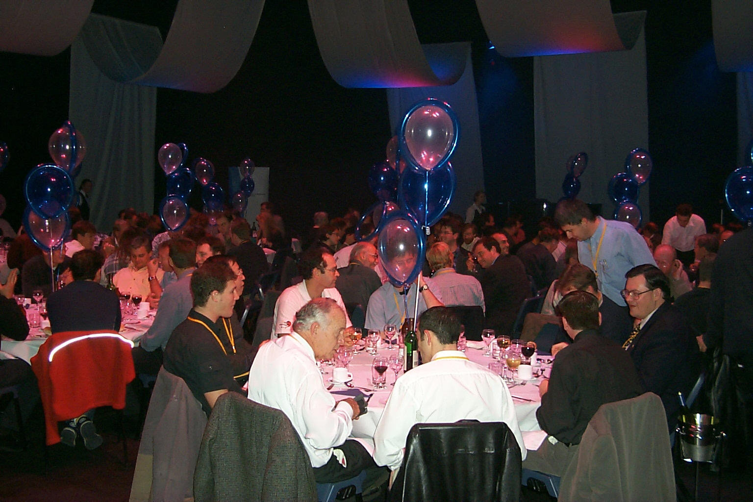

All in all the night was surely enjoyed by all.

Caught on Camera

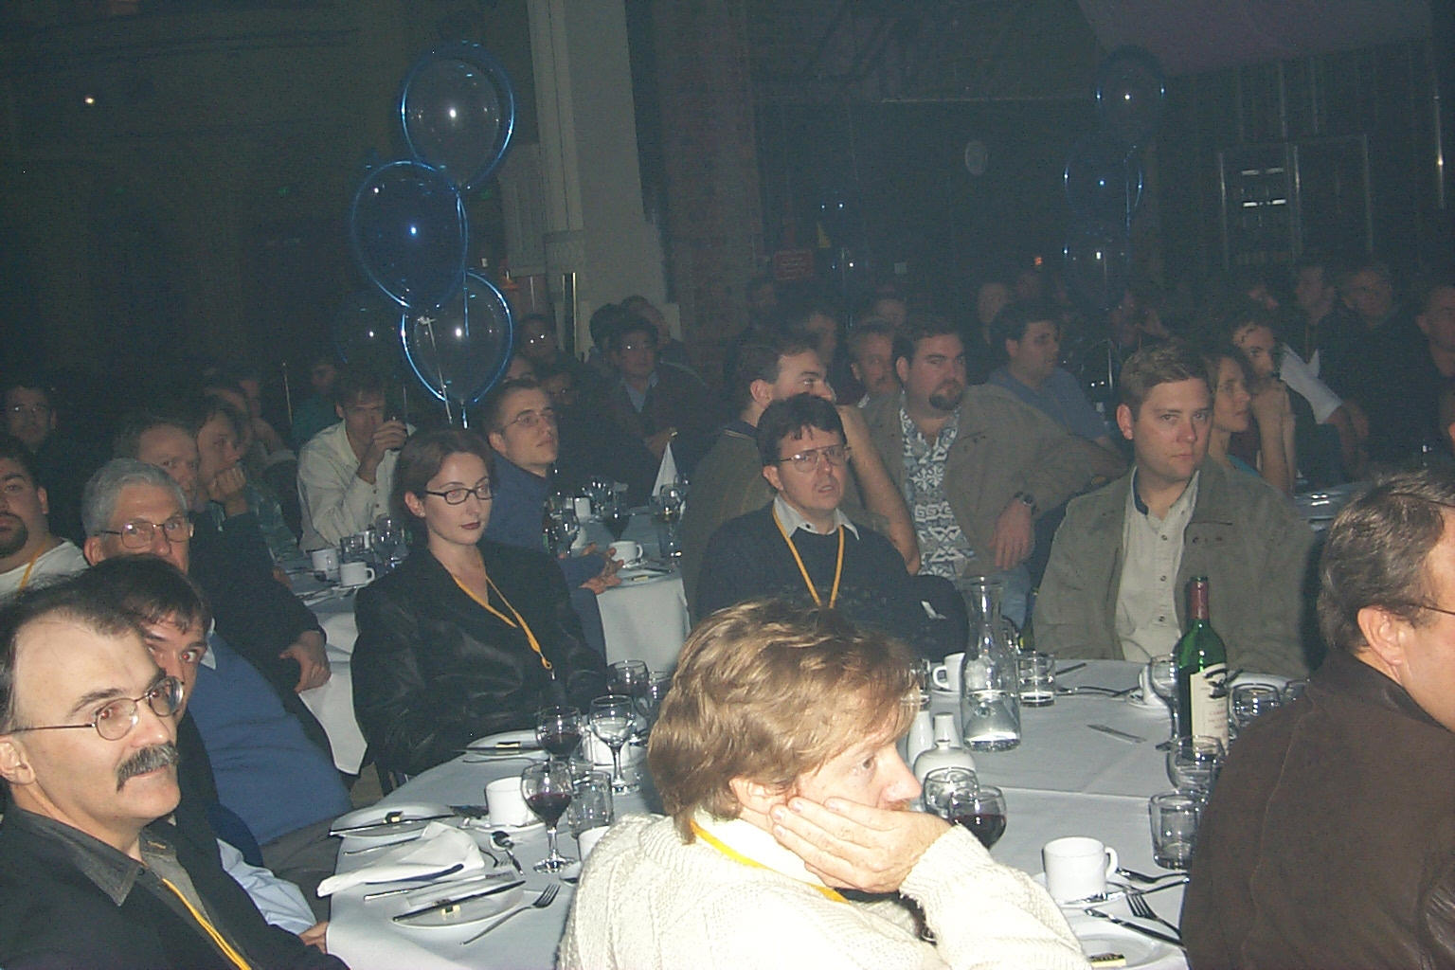

Enjoying the entertainment.

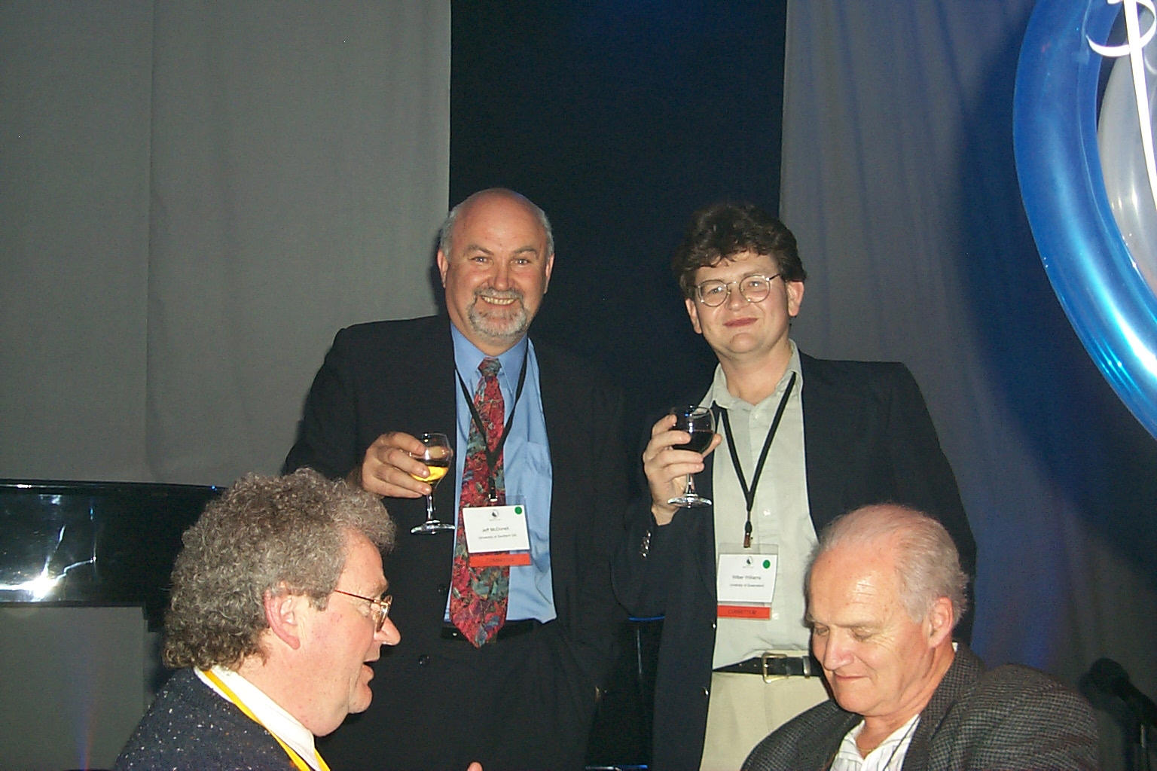
Getting tips for the next year!!

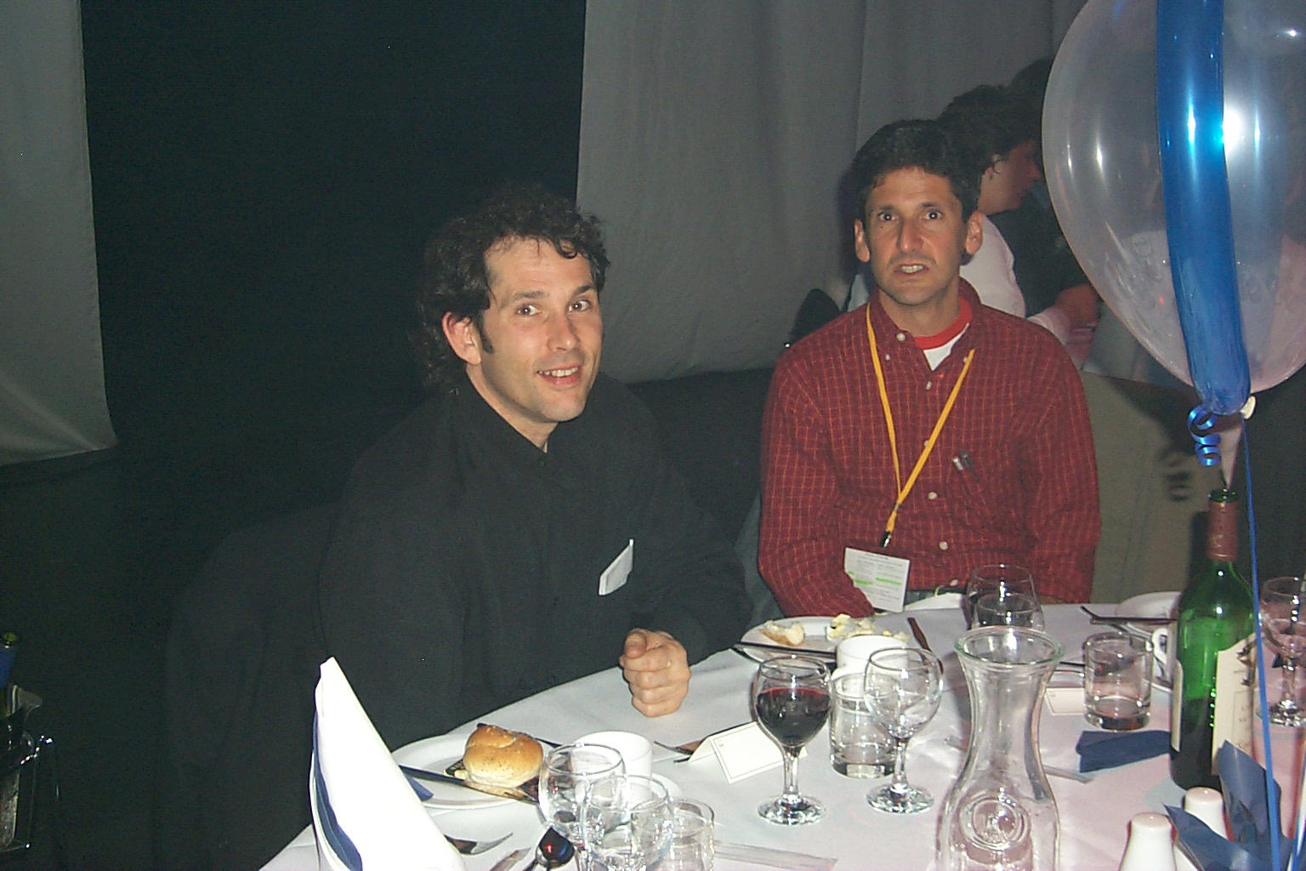

Where’s the food??

Would you trust this man with next years QUESTnet Conference?

